**OPPOSITION Nо B 3 198 676**

**Louis Vuitton Malletier, Société par Actions Simplifiée**, 2 rue du Pont-Neuf, 75001 Paris, France (opponent), represented by **Spheriens**, Piazza della Libertà 13 - Viale Don Minzoni 1, 50129 Firenze, Italy (professional representative)

a g a i n s t

**Qingjian Fu**, Via di Brozzi 552, 50145 Firenze, Italy (applicant), represented by **Nicola Maria Viscanti**, Via Simintendi 29, 59100 Prato, Italy (professional representative).

On 04/10/2024, the Opposition Division takes the following

**DECISION:**

|  |  |
| --- | --- |
| **1.** | Opposition No B 3 198 676 is upheld for all the contested goods. |

|  |  |
| --- | --- |
| **2.** | European Union trade mark application No 18 832 921 is rejected in its entirety. |

|  |  |
| --- | --- |
| **3.** | The applicant bears the costs, fixed at EUR 620. |

**REASONS**

On 30/06/2023, the opponent filed an opposition against all the goods of European Union trade mark application No 18 832 921 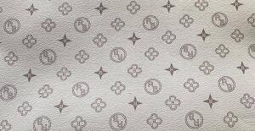 (pattern mark). The opposition is based on, *inter alia*, EUTM registration No 15 602, 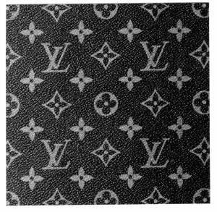 (figurative mark). The opponent invoked, *inter alia*, Article 8(5) EUTMR.

**REPUTATION — ARTICLE 8(5) EUTMR**

For reasons of procedural economy, the Opposition Division will first examine the opposition in relation to earlier EUTM registration No 15 602, for which the opponent claimed reputation in the European Union.

According to Article 8(5) EUTMR, upon opposition by the proprietor of a registered earlier trade mark within the meaning of Article 8(2) EUTMR, the contested trade mark will not be registered where it is identical with, or similar to, an earlier trade mark, irrespective of whether the goods or services for which it is applied are identical with, similar to or not similar to those for which the earlier trade mark is registered, where, in the case of an earlier European Union trade mark, the trade mark has a reputation in the Union or, in the case of an earlier national trade mark, the trade mark has a reputation in the Member State concerned and where the use without due cause of the contested trade mark would take unfair advantage of, or be detrimental to, the distinctive character or the repute of the earlier trade mark.

Therefore, the grounds for refusal of Article 8(5) EUTMR are only applicable when the following conditions are met.

• The signs must be either identical or similar.

• The opponent’s trade mark must have a reputation. The reputation must also be prior to the filing of the contested trade mark; it must exist in the territory concerned and for the goods and/or services on which the opposition is based.

• Risk of injury: use of the contested trade mark would take unfair advantage of, or be detrimental to, the distinctive character or repute of the earlier trade mark.

The abovementioned requirements are cumulative and, therefore, the absence of any one of them will lead to the rejection of the opposition under Article 8(5) EUTMR (16/12/2010, T-357/08, BOTOCYL / BOTOX, EU:T:2010:529, § 41; 16/12/2010, T-345/08, BOTOLIST / BOTOX, EU:T:2010:529, § 41). However, the fulfilment of all the abovementioned conditions may not be sufficient. The opposition may still fail if the applicant establishes due cause for the use of the contested trade mark.

In the present case, the applicant did not claim to have due cause for using the contested mark. Therefore, in the absence of any indications to the contrary, it must be assumed that no due cause exists.

**a) Reputation of the earlier trade mark**

Reputation implies a knowledge threshold that is reached only when the earlier mark is known by a significant part of the relevant public for the goods or services it covers. The relevant public is, depending on the goods or services marketed, either the public at large or a more specialised public.

In the present case, the contested trade mark was filed on 07/02/2023. Therefore, the opponent was required to prove that the trade mark on which the opposition is based had acquired a reputation  prior to that date. In principle, it is sufficient that the opponent show that its mark already had a reputation on that date. While it follows from the wording of Article 8(5) EUTMR that the conditions for its application also need to be present at the time of taking the decision, and therefore the reputation of the earlier mark must subsist until the decision on the opposition is taken, any subsequent loss of reputation is for the applicant to claim and prove.

The evidence must also show that the reputation was acquired for the goods for which the opponent has claimed reputation, namely:

Class 18: *Goods made of leather or of imitations of leather not included in other classes in particular boxes of leather or of leatherboard, envelopes of leather or of imitation of leather; trunks, valises, travelling bags, travelling sets, garment bags for travel, vanity-cases, chests, bags, rucksacks, handbags, beach bags, shopping bags, shoulder bags, suitcases, attaché-cases, briefcases, satchels, pouches, fine leather goods in particular pocket wallets, coin purses not of precious metal, purses, key-holders, card holders; umbrellas, parasols, sunshades, canes, walking-stick seats.*

Class 25: *Clothing, underwear and other clothing articles, in particular sweaters, shirts, dress bodies, corsets, suits, waistcoats, waterproofs clothing, skirts, coats, pullovers, trousers, dresses, clothing jackets, shawls, stoles, sashes for wear, scarves, neck ties, ties, pocket handkerchiefs for wear, braces, clothing gloves, clothing belts, stocking, tights, socks, bathing suits, bath robes; footwear; headgear for wear.*

The opposition is directed against the following goods:

Class 18: *Luggage, bags, wallets and other carriers.*

Class 25: *Clothing; footwear; headgear; parts of clothing, footwear and headgear.*

In order to determine the mark’s level of reputation, all the relevant facts of the case must be taken into consideration, including, in particular, the market share held by the trade mark, the intensity, geographical extent and duration of its use, and the size of the investment made by the undertaking in promoting it.

On 15/02/2024 the opponent submitted the following evidence:

- **Exhibits 1-3**: Excerpts of brand rankings elaborated by ‘MillwardBrown / Kantar’, featuring the “brandz Top 100 Brand Ranking 2008”, “BrandZ Most Valuable Global Brands” for the years 2009-2012, “BrandZ Top 100 Most Valuable Global Brands” for the years 2011, 2013-2020, “BrandZ 2021 Most Valuable Global Brands”, “BrandZ Most Valuable Global Brands” for 2022 and 2023 containing data between 2008-2023. that the brand ‘LOUIS VUITTON’ is placed within the first position however these documents refer to the signs , , , ‘LOUIS VUITTON’, but not to the opponent’s any other of the opponent’s marks.

- **Exhibit 4**: Two articles on the opponent’s Monogram, originating from the opponent, undated. The first article is titled ‘Louis Vuitton Savoir-Faire’ and describes the 150-year track history of the opponent, including a special section on the opponent’s Monogram, being conceived in 1896 and in 1959 soft bags made in Monogram canvas emerged. The second article is entitled ‘The creation of the Monogram canvas: a founder element of modern luxury’ and describes the process of inspiration and creation of the opponent’s Monogram and its continuous evolution, showing pictures of different products with the Monogram, including famous personalities carrying those products: 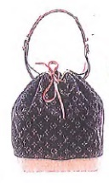, 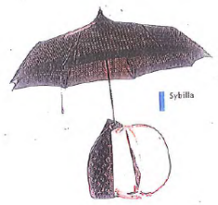, 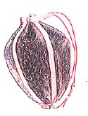, 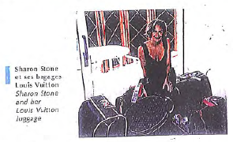, 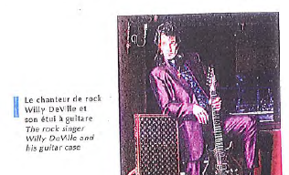.

- **Exhibits 5-10**: Copies of several of the opponent’s trade mark registrations at EUIPO, WIPO and INPI, some of them dating back to 1969.

- **Exhibit 11**: Extract of a book on the opponent’s trunks, dated in 2011 (according to the opponent), in Italian, originating from the opponent. It shows the evolution of the opponent’s trunks since 1906 until 1997. It contains pictures such as 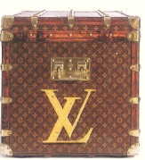,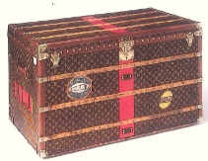, 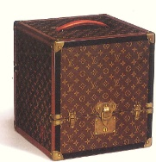, 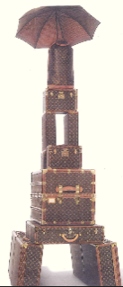, 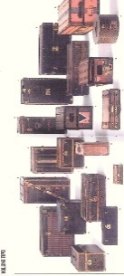, 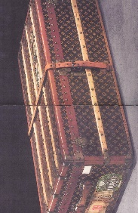.

- **Exhibits 12-20**: Excerpts of the opponent’s catalogues in English and French from 2006-2010, showing products with the opponent’s Monogram, such as: 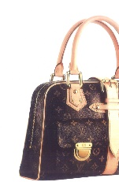, 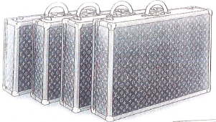, 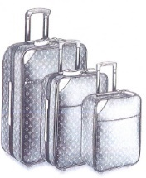, 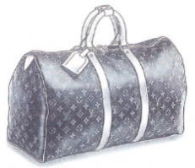, 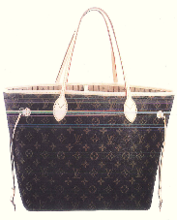, 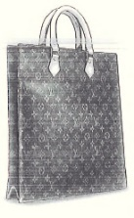, 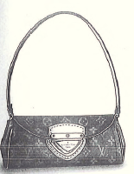, 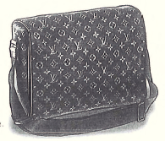, 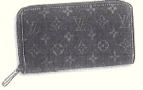, 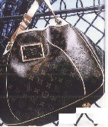, 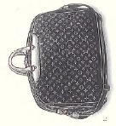, 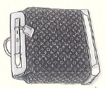, , 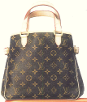, 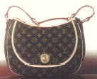, , , 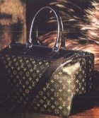, 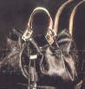, 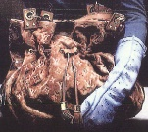.

- **Exhibits 21-32**: Excerpts from magazines in Italian, French, Spanish, German, Swedish, Dutch and Greek dated between 2006-2020. They contain images of products, mainly bags, with the opponent’s Monogram, such as: 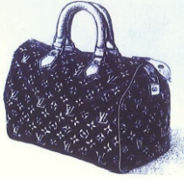, 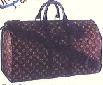, 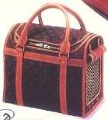, 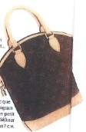, 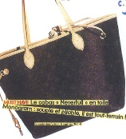, 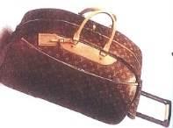, 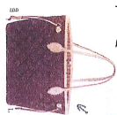, 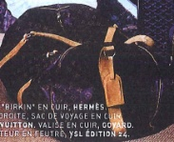, 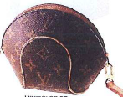, 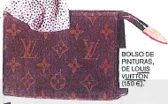, 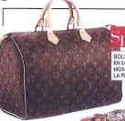, 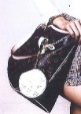, 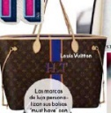, , , , 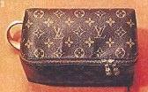, 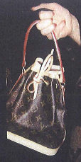,  . Some of these excerpts show cooperation with international stars (such as Selena Gomez) and the international organization UNICEF.

- **Exhibits 33-43**: Advertising materials dated between 2006-2011 (according to the opponent), in French and English, showing images of products with the opponent’s Monogram, such as: 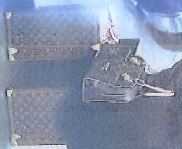, 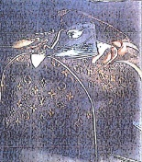 , 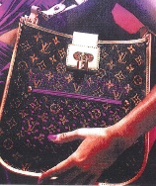 , 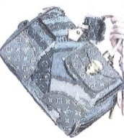 , 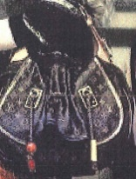. There are also press releases from the opponent, dated in October 2008, March 2008, June 2008, 2009, 2010, reporting the staring of advertising campaigns for the opponent’s products by famous personalities.The documents are in English and French.

- **Exhibit 44**: Printouts from the websites vogue.fr and vogue.com, dated on 03/06/2014 and 29/08/2017. These articles deal with Designer Monograms, with a special focus on the opponent’s Monogram. The articles are in English. According to one of the articles, ‘[a]s Louis Vuitton’s signature emblem since 1896, the iconic Monogram motif is currently being celebrated though the Icon and Iconoclasts project’.

- **Exhibit 45**: Printout of the opponent’s website containing an article titled ‘Six iconoclasts celebrating the Monogram’, in English, dated 09/2019. The article reports that six leading designers will collaborate with the opponent’s to redesign its Monogram. This exhibit also contains an article in a very similar vein published on the website *Yatzer* on 22/10/2014 in English. According to this article, ‘Louis Vuitton’s Celebrating Monogram project is, all in all, a salute to its universal icon’.

- **Exhibit 46**: Opponent’s profiles on Instagram and Twitter showing pictures of the opponent’s products, such as: 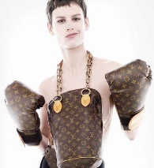, , 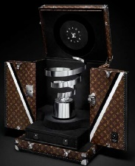, , 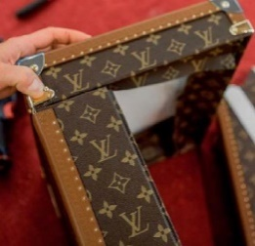, , 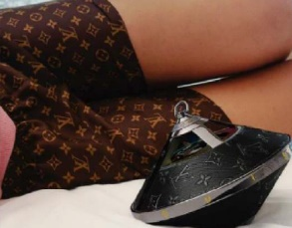, 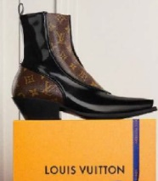, 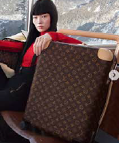 , 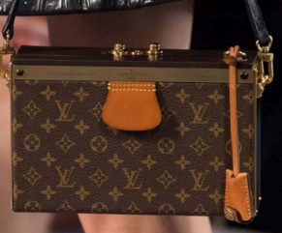, 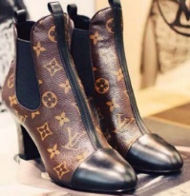, . The posts are dated between 05/03/2014 and 18/12/2022.

- **Exhibit 47**: Press clippings from the opponent on the opponent’s initiatives related to automotive competitions. They are dated between 1907 and 1998.

- **Exhibits 48-49**: Articles published on various specialised media and the opponent’s website between 01/06/2010 and 29/10/2015 and informing on the opponent’s design of a case for the Rugby World Cup 2015 and a case for FIFA World Cup Trophy 2010. The articles are in English, Spanish, Turkish, Italian, Portuguese, French, Japanese, Thai and Russian.

- **Exhibit 50**: Printouts of the opponent’s website showing opponent’s trunks and cases designed to hold trophies for sports competitions, such as: 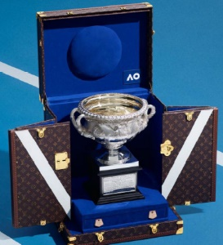, 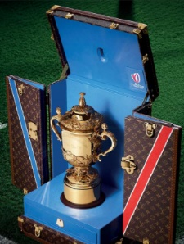, 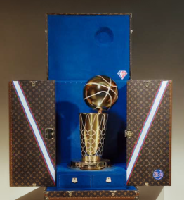 . Some of them refer to recent and well known events, such as the 2024 Australia Open, the 2022 Davis Cup, the 2017 and 2018 editions of the Roland Garros, the 2023 Rugby World Cup, the 2021 Formula 1 Grand Prix Monaco, the 2023 Ballon d’Or, the 2010, 2014, 2018 and 2022 FIFA World Cups, the 2024 America’s Cup.

- **Exhibit 51**: Pictures from the opponent’s advertising campaigns with celebrities: , , . They are undated, although the printouts in which they are presented are dated on 29/08/2016. The text of the campaigns is in English.

- **Exhibit 52**: Articles in specialised media reporting on the opponent’s campaign with football stars. The articles are in Italian and English, and dated on 19-22/11/2022.

- **Exhibits 53-77**: Decisions from the Office and national courts establishing the reputation of some of the opponent’s trade marks. The decisions are dated between 23/03/2005-15/10/2023 and have several paragraphs translated into English when applicable. Some of the decisions refer to the opponent’s monogram.

In order to determine the mark’s level of reputation, all the relevant facts of the case must be taken into consideration, including, in particular, the market share held by the trade mark, the intensity, geographical extent and duration of its use, and the size of the investment made by the undertaking in promoting it.

The abovementioned evidence indicates that the earlier trade mark has been used for a substantial period of time. Despite some outdated documents, the opponent’s advertising efforts, including the opponent’s participation and sponsorship in international and well known sports competitions followed by millions of people (such as the 2024 Australia Open, the 2022 Davis Cup, the 2017 and 2018 editions of the Roland Garros, the 2023 Rugby World Cup, the 2021 Formula 1 Grand Prix Monaco, the 2023 Ballon d’Or, the 2010, 2014, 2018 and 2022 FIFA World Cups, the 2024 America’s Cup) are remarkable. Indeed, the marketing/advertising efforts (exhibits 33-43, 46, 51-52), along with the production of trophy trucks with the opponent’s monogram for sports competitions (exhibits 48-50) suggest that the trade mark has a consolidated position in the market. These promotional activities show that the opponent has undertaken steps to build up a brand image and enhance trade mark awareness among the public.

Moreover, several press articles refer to the opponent’s trademark as ‘universal icon’ (exhibit 45) and as ‘iconic’ (exhibit 44), which reflect the perception of the opponent’s trade mark among consumers.

In addition, the opponent showed a longstanding use for more than 15 years -there are catalogues which date back to 2006 (exhibits 12-20), mentions in magazines from 2006 to 2020 (exhibits 21-32) and pictures on Instagram of products with the opponent’s trade mark dating between 2014 and 2022 (exhibit 46).

These findings are aligned with some of the previous decisions of the national courts, national offices and of the Office submitted by the opponent. In particular, the Decision R 582/20198-5 of the Fifth Board of Appeal of 03/11/2020 stated that the ‘cancellation applicant’s ‘Monogram canvas’ is undeniably widely known on the relevant territory due to its well-documented, long-standing and intensive use’.

The excerpts from magazines in, inter alia, Italian and French (exhibits 21-32), the advertising materials in French and English (exhibits 33-43), press clippings and articles in English (inter alia, exhibits 44-45, 47-49) and articles reporting the opponent’s advertising campaigns in Italian and English (exhibit 52) prove that the reputation of the opponent’s mark is proven at least in some European countries (Italy and France).

According to Article 8(5) EUTMR, the relevant territory for establishing the reputation of the earlier mark is the territory of protection: the earlier mark must have a reputation in the territory where it is registered. Therefore, for EUTM the relevant territory is the European Union. However, the Court has clarified that for an earlier European Union trade mark, reputation throughout the territory of a single Member State may suffice. The Court indicated that a EUTM must be known in a substantial part of the EU by a significant part of the public concerned by the goods and services concerned by that trade mark. When evaluating whether the part of the territory in question is a substantial one, account must be taken both of the size of the geographical area concerned and of the proportion of the overall population living there, since both these criteria may affect the overall significance of the specific territory (06/10/2009), C-301/17, Pago, EU:C:2009/611).

In the present case, it is considered that the reputation of the earlier mark is demonstrated at least in Italy and France which already constitutes a substantial part of the EU population and that there are also indications of some reputation in other countries of the European Union such as Spain, Germany, Sweden, The Netherlands and Greece.

On the basis of the above, the Opposition Division concludes that the earlier trade mark has certain reputation at least in Italy and France at least for *bags* in Class 18.

**b) The signs**

|  |  |
| --- | --- |
|  |  |
| Earlier trade mark | Contested sign |

The relevant territory is the European Union.

The global appreciation of the visual, aural or conceptual similarity of the marks in question must be based on the overall impression given by the marks, bearing in mind, in particular, their distinctive and dominant components (11/11/1997, C‑251/95, Sabèl, EU:C:1997:528, § 23).

The unitary character of the European Union trade mark means that an earlier European Union trade mark can be relied on in opposition proceedings against any application for registration of a European Union trade mark that would adversely affect the protection of the first mark, even if only in relation to the perception of consumers in part of the European Union (18/09/2008, C‑514/06 P, ARMAFOAM / NOMAFOAM, EU:C:2008:511, § 57). Since reputation has been demonstrated in, at least, Italy and France, the analysis below focuses on the Italian and French public.

The earlier marks consist of a repetition of elements resembling flowers and stars, as well as elements with the intertwined letters ‘L’ and ‘V’. The contested sign also consists of a repetition of decorative elements resembling flowers with a letter ‘B’ inside and stars with the letter ‘R’ inside, as well as elements containing the letters ‘R’ and ‘B’ enclosed in a circle. This circle is non distinctive because it is only a background to the letters ‘R’ and ‘B’, which is commonly used in the market.

The letters combination ‘L’ and ‘V’ of the earlier marks and ‘R’, ‘B’ and ‘RB’ of the contested sign do not present any clear and unambiguous meaning, and, therefore, they are distinctive to a normal degree.

Elements resembling flowers and stars are commonly used in trade as decorations. Indeed, stylised star-shaped devices are essentially decorative. In addition, flowers are often encountered used in the decorative sense in a wide variety of contexts, and especially in relation to clothing, footwear and headgear. The public will not perceive as distinctive a flower design on fashion wear and accessories (27/08/2024, R 2543/2023-2, SELENACARE (fig.) / SELENE et al., § 26). Therefore, although slightly stylized, the flowers and stars depicted in the marks under comparison are weak.

The earlier mark’s elements are depicted in beige against a dark background. The contested sign’s elements are depicted in brown against a beige background. Both backgrounds are decorative and non-distinctive.

The marks have no elements that can be considered more dominant than other elements.

**Visually**, the signs coincide in the use of repeated elements resembling stars and flowers. However, the signs differ in the specific shape of the ends of those elements (sharper or rounder) and in the presence of different letters in the signs: ‘L’ and ‘V’ in the earlier marks and ‘R’ and ‘B’ in the contested sign. Moreover, the contested sign’s letters are embedded in circles, flowers and stars whereas the earlier marks’ letters are not.

Although the differences lie in the only distinctive elements of the marks whereas the partial coincidences are in weak elements, the overall structure of the contested sign consisting in the repetition of flowers, stars and letters is similar to the overall structure of the contested sign..

Therefore, taking into account the degrees of distinctiveness of the different elements, the signs are visually similar to a low degree.

**Aurally**, the public will refer to the marks by their verbal elements and, therefore, irrespective of the different pronunciation rules, the signs differ in the sound of the letters ‘L’ and ‘V’ of the earlier marks and ‘R’ and ‘B’ of the contested sign.

Therefore, the signs are aurally dissimilar.

**Conceptually**, the signs coincide in the concept of stars and flowers, which are non-distinctive. Therefore, the signs are conceptually similar only to a low degree.

Taking into account that the signs have been found similar in at least one aspect of the comparison, the examination of the existence of a risk of injury will proceed.

**c) The ‘link’ between the signs**

As seen above, the earlier mark is reputed and the signs are similar to some extent. In order to establish the existence of a risk of injury, it is necessary to demonstrate that, given all the relevant factors, the relevant public will establish a link (or association) between the signs. The necessity of such a ‘link’ between the conflicting marks in consumers’ minds is not explicitly mentioned in Article 8(5) EUTMR but has been confirmed by several judgments (23/10/2003, C‑408/01, Adidas, EU:C:2003:582, § 29, 31; 27/11/2008, C‑252/07, Intel, EU:C:2008:655, § 66). It is not an additional requirement but merely reflects the need to determine whether the association that the public might establish between the signs is such that either detriment or unfair advantage is likely to occur after all of the factors that are relevant to the particular case have been assessed.

Possible relevant factors for the examination of a ‘link’ include (27/11/2008, C‑252/07, Intel, EU:C:2008:655, § 42):

• the degree of similarity between the signs;

• the nature of the goods and services, including the degree of similarity or dissimilarity between those goods or services, and the relevant public;

• the strength of the earlier mark’s reputation;

• the degree of the earlier mark’s distinctive character, whether inherent or acquired through use;

• the existence of likelihood of confusion on the part of the public.

This list is not exhaustive and other criteria may be relevant depending on the particular circumstances. Moreover, the existence of a ‘link’ may be established on the basis of only some of these criteria.

The establishment of such a link, while triggered by similarity between the signs, requires that the relevant sections of the public for each of the goods and services covered by the trade marks in dispute are the same or overlap to some extent.

The earlier mark has a normal degree of inherent distinctiveness, and it enjoys a certain degree of reputation in at least, Italy and France in relation to, at least, *bags* in Class 18.

The contested goods are the following:

Class 18: *Luggage, bags, wallets and other carriers.*

Class 25: *Clothing; footwear; headgear; parts of clothing, footwear and headgear.*

There is a close connection between the contested goods and the goods for which the earlier mark enjoys reputation on the market from the consumers’ perspective. In particular, the opponent’s *bags* are identical to the contested *luggage, bags* in Class 18 because they are included in or overlap with the latter. Regarding the contested *wallets and other carriers* in this class, are often used together, as additional pouches to carry small items. Sometimes, designers produce all sorts of bags and carriers with the same or similar motifs as part of a collection. They are similar to the *bags* for which the earlier mark enjoys reputation because they usually coincide in producer, relevant public and distribution channels.

Regarding the contested *clothing; footwear; headgear* in Class 25, these are often combined with bags and can be sometimes offered in the same shops. In this vein, it is not uncommon that clothing, footwear and headgear specially designed for travelling is also paired with travelling bags. It is not only a matter of visual style, but also of the materials used, which may render the items specially adequate for the climate of the place to which the consumer is travelling to.

The remaining contested *parts of clothing, footwear and headgear* in Class 25 and the opponent’s *bags* in Class 18 share materials, functional similarities, and design patterns. Many clothing, footwear and headgear items, as well as traveling bags are made from durable, versatile materials like nylon, polyester, leather, or canvas, chosen for their strength, water resistance, and ease of cleaning. Bags, clothing, headgear and footwear often borrow elements from each other, such as padded straps, reinforced stitching, and reflective materials, to create functional and practical products. These goods are part of the same fashion field because same part of clothing footwear and headgear maybe sold as separate parts in the shops where fashion items are sold.

Although the similarity between the signs is low and the earlier mark enjoys only a certain reputation, the fact remains that, despite the different letters, the structure of the signs is similar (same patterns alternating flowers-stars-letters, the presence of circles) and, as explained above, the contested goods and the goods for which the earlier mark enjoys reputation are identical, similar or, in any case, belong to the same fashion field. Consequently, having regard to and assessing all the relevant factors of the present case, it is concluded that, when encountering the contested mark, the relevant consumers in the Italy and France will be likely to associate it with the earlier sign; that is to say, establish a mental ‘link’ between the signs. The existence of a ‘link’ between the signs is a necessary condition for further assessing the risk that use of the contested trade mark would take unfair advantage of, or be detrimental to, the distinctive character or the repute of the earlier trade mark. However, the existence of such a link is not sufficient, in itself, to conclude that one of the types of injury referred to in Article 8(5) EUTMR exists (26/09/2012, T‑301/09, CITIGATE / CITICORP et al., EU:T:2012:473, § 96).

**d) Risk of injury**

Use of the contested mark will fall under Article 8(5) EUTMR when any of the following situations arise:

• it takes unfair advantage of the distinctive character or the repute of the earlier mark;

• it is detrimental to the repute of the earlier mark;

• it is detrimental to the distinctive character of the earlier mark.

Although detriment or unfair advantage may be only potential in opposition proceedings, a mere possibility is not sufficient for Article 8(5) EUTMR to be applicable. While the proprietor of the earlier mark is not required to demonstrate actual and present harm to its mark, it must ‘adduce prima facie evidence of a future risk, which is not hypothetical, of unfair advantage or detriment’ (06/07/2012, T‑60/10, ROYAL SHAKESPEARE / RSC- ROYAL SHAKESPEARE COMPANY et al., EU:T:2012:348, § 53).

It follows that the opponent must establish that detriment or unfair advantage is probable, in the sense that it is foreseeable in the ordinary course of events. For that purpose, the opponent should file evidence, or at least put forward a coherent line of argument demonstrating what the detriment or unfair advantage would consist of and how it would occur, that could lead to the prima facie conclusion that such an event is indeed likely in the ordinary course of events.

**Unfair advantage (free-riding)**

Unfair advantage in the context of Article 8(5) EUTMR covers cases where there is clear exploitation and ‘free-riding on the coat-tails’ of a famous mark or an attempt to trade upon its reputation. In other words, there is a risk that the image of the mark with a reputation or the characteristics which it projects are transferred to the goods and services covered by the contested trade mark, with the result that the marketing of those goods and services is made easier by their association with the earlier mark with a reputation (06/07/2012, T‑60/10, ROYAL SHAKESPEARE / RSC- ROYAL SHAKESPEARE COMPANY et al., EU:T:2012:348, § 48; 22/03/2007, T‑215/03, VIPS / VIPS, EU:T:2007:93, § 40).

The opponent bases its claim on the argument that ‘the “Toile Monogram” has become a vehicle for communicating a general message of luxury, exclusivity, and elegance to the public. Therefore, by using a highly similar pattern on his products, the Applicant would immediately add value to his activity and substantially save on his marketing and advertising investments, by benefitting from a transfer of this positive message to its products.’

According to the Court of Justice of the European Union

… as regards injury consisting of unfair advantage taken of the distinctive character or the repute of the earlier mark, in so far as what is prohibited is the drawing of benefit from that mark by the proprietor of the later mark, the existence of such injury must be assessed by reference to average consumers of the goods or services for which the later mark is registered, who are reasonably well informed and reasonably observant and circumspect.

(27/11/2008, C-252/07, Intel, EU:C:2008:655, § 36.)

To determine whether the use of a sign takes unfair advantage of the distinctive character or the repute of the mark, it is necessary to undertake an overall assessment, which takes into account all the factors relevant to the circumstances of the case (10/05/2007, T‑47/06, NASDAQ (fig.) / NASDAQ, EU:T:2007:131, § 53; 12/03/2009, C‑320/07 P, NASDAQ (FIG.) / NASDAQ, EU:C:2009:146; 23/10/2003, C‑408/01, Adidas, EU:C:2003:582, § 29, 30, 38; 27/11/2008, C‑252/07, Intel, EU:C:2008:655, § 57, 58, 66; 24/03/2011, C‑552/09 P, TiMi KiNDERJOGHURT / KINDER, EU:C:2011:177, § 53).

The applicant’s intention is not a material factor. Taking unfair advantage of the distinctiveness or the repute of a trade mark may be a deliberate decision, for example, where there is clear exploitation and free-riding on the coat-tails of a famous mark, or an attempt to trade upon the reputation of a famous mark. However, taking unfair advantage does not necessarily require a deliberate intention to exploit the goodwill attached to someone else’s trade mark. The concept of taking unfair advantage ‘concerns the risk that the image of the mark with a reputation or the characteristics that it projects are transferred to the goods and services covered by the mark applied for, with the result that the marketing of those goods and services is made easier by that association with the earlier mark with a reputation’ (19/06/2008, T‑93/06, MINERAL SPA /(fig.) SPA et al, EU:T:2008:215, § 40; 22/03/2007, T‑215/03, VIPS / VIPS, EU:T:2007:93, § 40; 30/01/2008, T‑128/06, (fig.) CAFÉ TORREFACTO CAMPO MAIOR CAMELO CAFÉ ESPECIAL PURO Torrefacçao Camelo Lda. CAMPO MAIOR-PORTUGAL / (fig.) CAMEL et al., EU:T:2008:22, § 46).

The earlier mark has certain reputation, and there are some similarities between the marks and an important degree of proximity between the conflicting goods from the perspective of the consumers in Italy and France. Consequently, it is concluded that the relevant public will make a connection between the marks; an association that will produce a commercial benefit for the applicant. There is a high probability that the use of the mark applied for may lead to free-riding; that is to say, it would take unfair advantage of the reputation of the earlier mark and the considerable investments undertaken by the opponent to achieve that reputation.

Therefore, the Opposition Division concludes that use of the contested trade mark is likely to take unfair advantage of the repute of the earlier trade mark in Italy and France.

**Other types of injury**

The opponent also argues that use of the contested trade mark would be detrimental to the distinctive character and repute of the earlier mark.

As seen above, the existence of a risk of injury is an essential condition for Article 8(5) EUTMR to apply. The risk of injury may be of three different types. For an opposition to be well founded in this respect it is sufficient if only one of these types is found to exist. In the present case, as seen above, the Opposition Division has already concluded that the contested trade mark would take unfair advantage of the distinctive character or repute of the earlier trade mark. It follows that there is no need to examine whether other types also apply.

**f) Conclusion**

Considering all the above, the opposition is well founded under Article 8(5) EUTMR. Therefore, the contested trade mark must be rejected for all the contested goods.

Given that the opposition is entirely successful under Article 8(5) EUTMR, it is not necessary to examine the remaining ground and earlier rights on which the opposition was based.

**COSTS**

According to Article 109(1) EUTMR, the losing party in opposition proceedings must bear the fees and costs incurred by the other party.

Since the applicant is the losing party, they must bear the opposition fee as well as the costs incurred by the opponent in the course of these proceedings.

According to Article 109(1) and (7) EUTMR and Article 18(1)(c)(i) EUTMIR, the costs to be paid to the opponent are the opposition fee and the costs of representation, which are to be fixed on the basis of the maximum rate set therein.



**The Opposition Division**

|  |  |  |
| --- | --- | --- |
| Angela DI BLASIO | María Aránzazu GANDIA SELLENS | Aldo BLASI |

According to Article 67 EUTMR, any party adversely affected by this decision has a right to appeal against this decision. According to Article 68 EUTMR, notice of appeal must be filed in writing at the Office within two months of the date of notification of this decision. It must be filed in the language of the proceedings in which the decision subject to appeal was taken. Furthermore, a written statement of the grounds for appeal must be filed within four months of the same date. The notice of appeal will be deemed to have been filed only when the appeal fee of EUR 720 has been paid.